CprE 419 Lab 10: Child Safety System in a Shopping Center

**Shuo Wang**

Figure 1 shows the streams dataflow graph for my code.

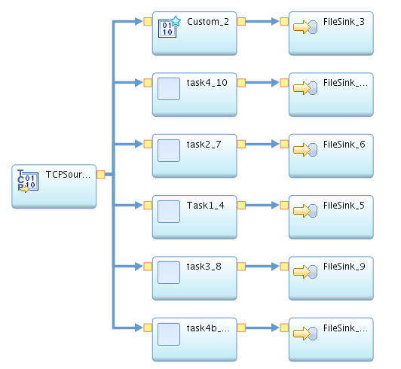

**FIGURE 1** Streams Dataflow Graph

TCPSource generates raw data

Custom_2 and FileSink_3 write the raw data in “rawdata.txt” to archive the streams data.

Task1 reports the children location every 2 min and the corresponding FileSink writes the output into “LocationLog.txt”

task2 generates the missing children alerts and the corresponding FileSink writes the output into “MissingChildAlert.txt”

task3 generates the alerts when children spend too much time in room 26 and the corresponding FileSink writes the output into “UnsafeRoomAlert.txt”

task4 generates the room statistics every 5 min and the corresponding FileSink writes the output into “RoomStats.txt”

task4b generates the child statistics every 5 min and the corresponding FileSink writes the output into “ChildStats.txt”

The details of each Java primitive operator can be found in the submission files.

I run the code for 20 minutes from 12:30 am to 12:50 April 16, 2015, and the records raw stream data can be found in rawdata.txt

**Appendix: files in submission .zip**

1. lab10.spl is the IBM Infosphere code for lab 10

2. Task1.java is the java code for Task1 java primitive operator

3. task2.java is the java code for task2 java primitive operator

4. task3.java is the java code for task3 java primitive operator

5. task4.java is the java code for task4 java primitive operator

6. task4b.java is the java code for task4b java primitive operator

7. “LocationLog.txt” is the output from task1

8. “MissingChildAlert.txt” is the output from task2

9. “UnsafeRoomAlert.txt” is the output from task3

10. “RoomStats.txt” is the output from task4

11. “ChildStats.txt” is the output from task4b

12. “rawdata.txt” is the archived stream data